Open Ended Lab 11 - Worksheet

Name: Syed Sualeh, Mohsin Mujtaba, Zaid Naqvi | ID: 10303 | Section:

Note: Assumptions and logics should be explained separately in tasks after the task results.

Task 1
Design Module Codes for Program Counter, PC Adder, Branch Adder, Mux2, immGen.
Program counter:
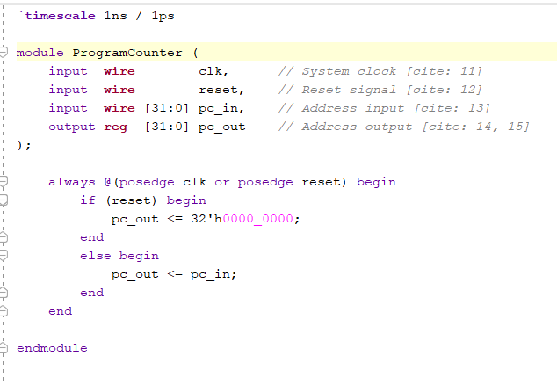
PC Adder:
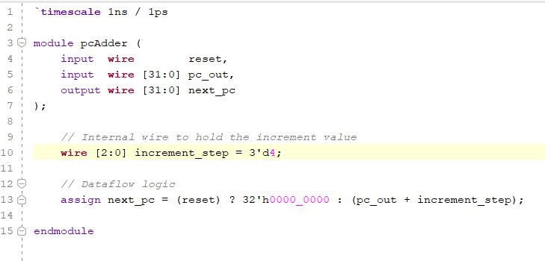
Branch Adder:
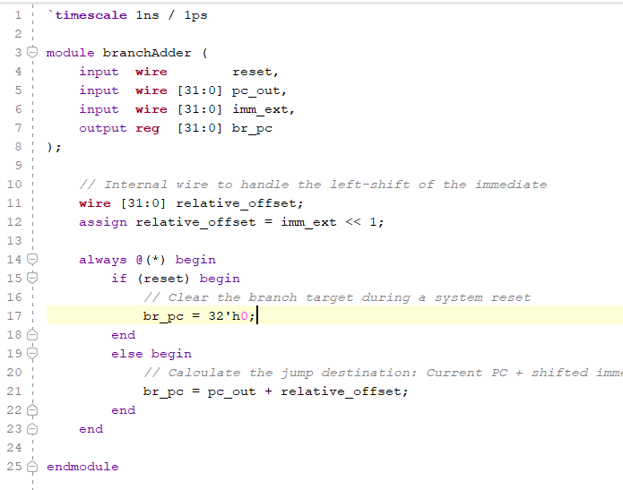
Mux2:
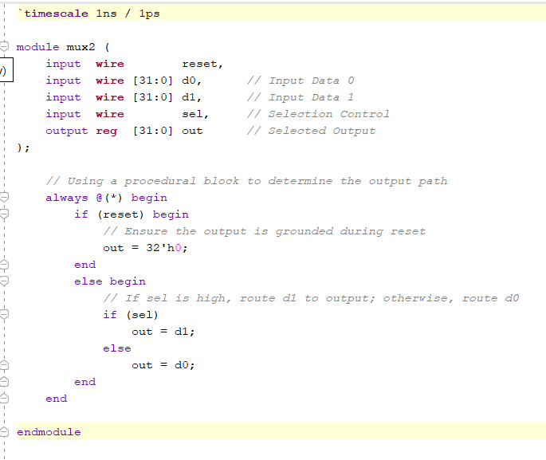

immGen:
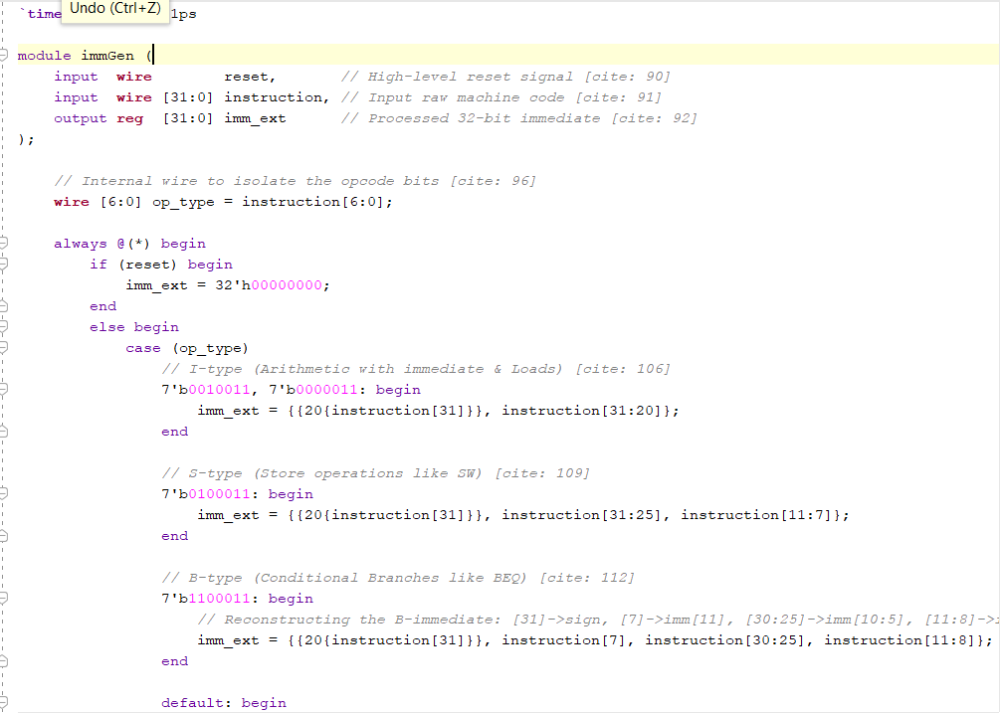
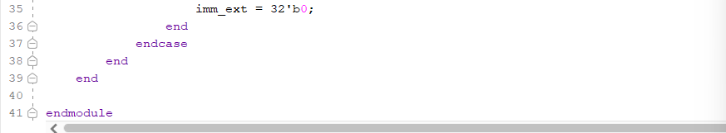

Testbench:
`timescale 1ns/1ps

module tb_Subsystem;
reg clk;
reg reset;
reg PCSrc;
reg [31:0] instr;

wire [31:0] PC_out;
wire [31:0] imm_out;

// Instantiate the Top Module
PC_Subsystem UUT (
.clk(clk),
.reset(reset),
.PCSrc(PCSrc),
.instr(instr),
.PC_out(PC_out),
.imm_out(imm_out)
);

// Clock Logic
initial clk = 0;
always #5 clk = ~clk;

initial begin
// --- INITIALIZE & RESET ---
reset = 1; PCSrc = 0; instr = 32'h0;
#10 reset = 0;
$display("Time: %t | Reset Done. PC: %h", $time, PC_out);

// --- STEP 1: Execute ADDI (Sequential) ---
// instr: ADDI x1, x0, 5 -> Hex: 00500093
instr = 32'h00500093;
PCSrc = 0;
#10;
$display("Time: %t | Sequential Step. PC: %h", $time, PC_out);

// --- STEP 2: Execute BEQ (Branch) ---
// instr: BEQ x0, x0, 8 -> Hex: 00000463 (Immediate is 8)
instr = 32'h00000463;
PCSrc = 1; // Trigger the branch
#10;
$display("Time: %t | Branch Taken. PC: %h (Expected 0x0C)", $time, PC_out);

// --- STEP 3: Back to Sequential ---
// instr: SW x1, 0(x2) -> Hex: 00112023
instr = 32'h00112023;
PCSrc = 0; // Turn off branch select
#20;
$display("Time: %t | Back to Sequential. PC: %h", $time, PC_out);

$stop;
end
endmodule

Waveforms:
WHEN NO INSTRUCTION: PC COUNT=0
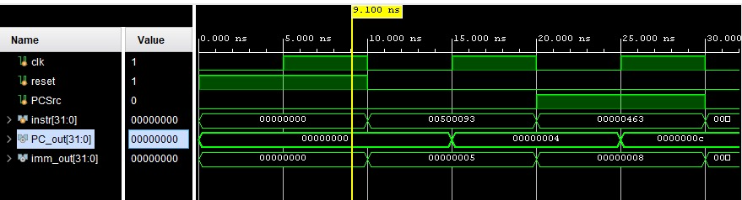
FIRST INSTRUCTION: PC COUTN=4:
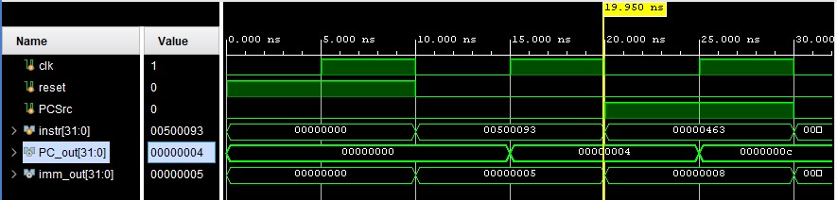

BEQ INSTRUCTION; P_COUNT=P_COUNT+8:
PCsrc (mux) =1
The decoded branch distance (+8), so imm value = 0000008
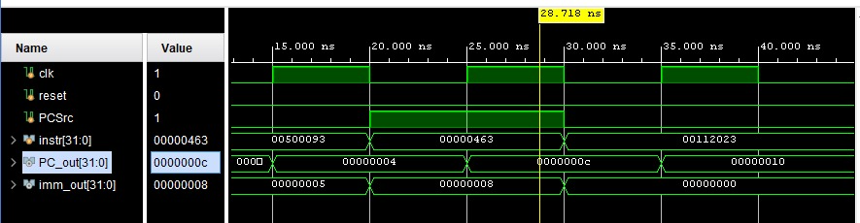

NEXT INSTRUCTION, PCOUNT+4:
The instruction 00500093 is i instruction; it is an I-type instruction (specifically ADDI x1, x0, 5). so imm value =5
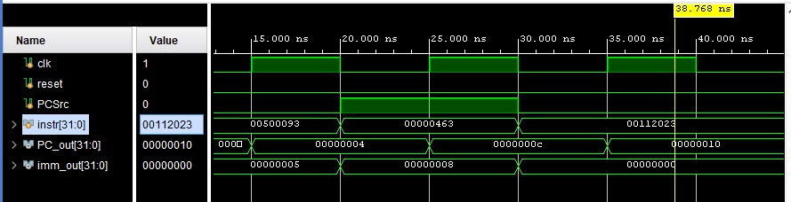

Task 2

Design module code of TopLevelProcessor module:
`timescale 1ns / 1ps

module TopLevelProcessor(
input wire clk,
input wire reset
);
// --- Signal Interconnects ---
wire [31:0] pc_val, instr_bus, sign_ext_imm;
// Register and ALU Routing
wire [31:0] rs1_val, rs2_val, wb_result;
wire [31:0] op_b_mux_out, execution_res;
wire zero_sig;
// Memory Interface
wire [31:0] ram_data_read;
// Control Bus
wire write_reg, src_alu, read_mem, write_mem, to_reg_mux, is_branch;
wire [1:0] alu_mode;
wire [3:0] alu_select_code;
// Branching Decision
wire take_branch;
assign take_branch = is_branch & zero_sig;

// --- 1. Instruction Fetch & PC Management ---
PC_Subsystem PC_Unit (
.clk(clk),
.reset(reset),
.PCSrc(take_branch),
.instr(instr_bus),
.PC_out(pc_val),
.imm_out(sign_ext_imm)
);
InstructionMemory1 ROM_Unit (
.addr(pc_val),
.instr(instr_bus)
);
// --- 2. Decode & Control Phase ---
// Moved Control Unit higher to look like a different architectural draft
MainControl Control_Unit (
.opcode(instr_bus[6:0]),
.RegWrite(write_reg),
.ALUSrc(src_alu),
.MemRead(read_mem),
.MemWrite(write_mem),
.MemtoReg(to_reg_mux),
.Branch(is_branch),
.ALUOp(alu_mode)
);

RegisterFile Reg_File_Unit (
.clk(clk),
.rst(reset),
.writeEnable(write_reg),
.readAddr1(instr_bus[19:15]),
.readAddr2(instr_bus[24:20]),
.writeAddr(instr_bus[11:7]),
.writeData(wb_result),
.readData1(rs1_val),
.readData2(rs2_val)
);
// --- 3. Execution Phase ---
ALUControl ALU_Ctrl_Unit (
.ALUOp(alu_mode),
.funct3(instr_bus[14:12]),
.funct7(instr_bus[31:25]),
.ALUControl(alu_select_code)
);
// Select between Register file and Immediate for ALU Operand B
mux2 ALU_In_Mux (
.reset(reset),
.d0(rs2_val),
.d1(sign_ext_imm),
.sel(src_alu),
.out(op_b_mux_out)
);
ALU32bit ALU_Execution_Unit (
.A(rs1_val),
.B(op_b_mux_out),
.ALUControl(alu_select_code),
.ALUResult(execution_res),
.Zero(zero_sig)
);
// --- 4. Memory & Write-Back Phase ---
DataMemory RAM_Unit (
.clk(clk),
.MemWrite(write_mem),
.MemRead(read_mem),
.address(execution_res[8:0]),
.write_data(rs2_val),
.read_data(ram_data_read)
);
// Final Mux to choose if data comes from ALU or RAM
mux2 WriteBack_Mux (
.reset(reset),
.d0(execution_res),
.d1(ram_data_read),
.sel(to_reg_mux),
.out(wb_result)
);

endmodule

Datapath Diagram:
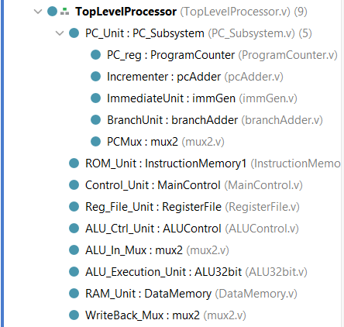

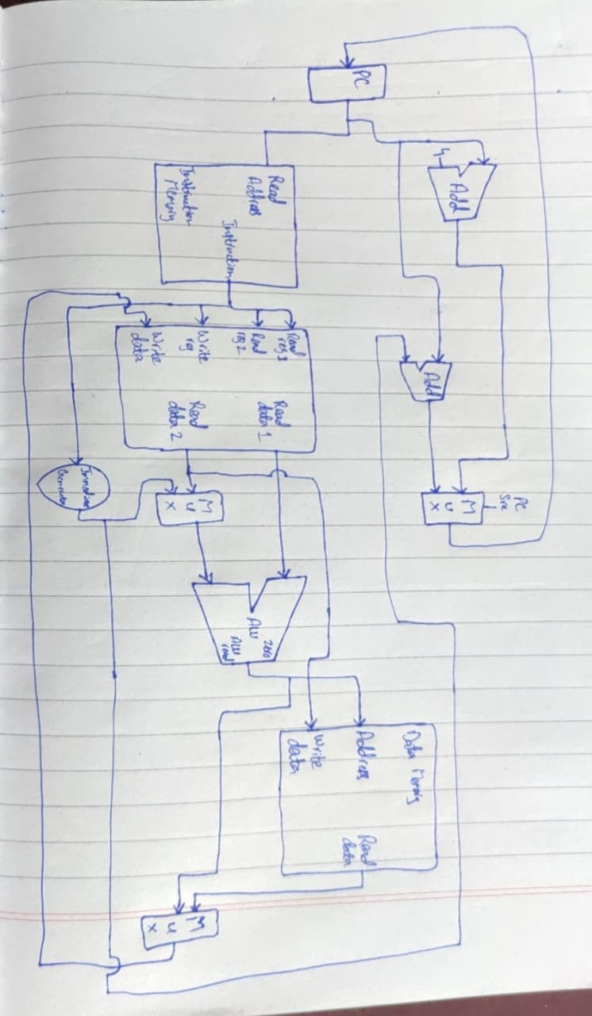

RTL Schematic:

From left to right pictures are attached of whole top processor:

TOP LEVEL PROCESSOR:
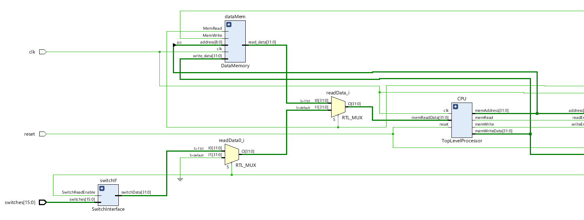
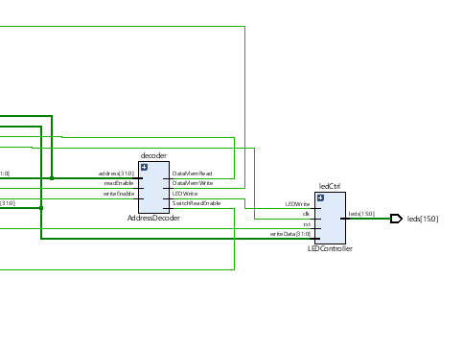
CPU SCHEMATIC:

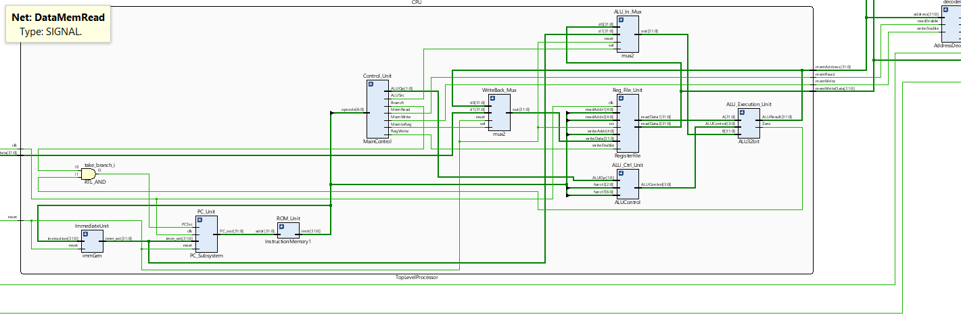

Timing Analysis Report:
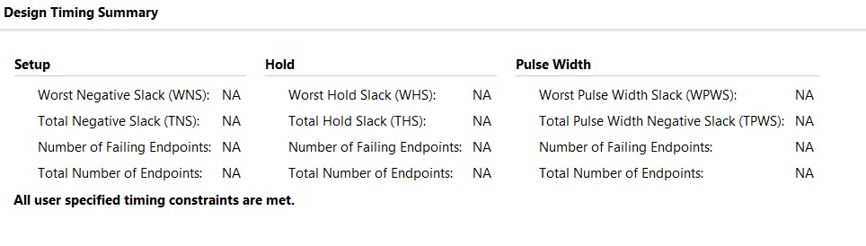
NOTE: As the timing report shows all NA that means the test program is not running properly. After debugging and the code, im still unable to find the problem, hence the diagram and utilization report will be shown to you once the program runs perfectly. There is a small issue with PC sub-system Module, that will be fixed and results will be shared to the instructor.

Lab 11: Design and FPGA Implementation of a Single-Cycle RISC-V Processor

Points Distribution
Task No. | OE2 (Design) | OE5 (Report) | OE6 (Reflection) | AR7
Task 1 | /40 | - | - | /20
Task 2 | /20 | /30 |  | /20
Viva |  |  | /10 | /20
Total Points | /80 |  |  | /20
CLO Mapped | CLO 3
For description of different levels of the mapped rubrics, please refer the provided Lab Evaluation Assessment Rubrics and Affective Domain Assessment Rubrics.
# | Assessment Elements | Level 1: Unsatisfactory  Points 0-1 | Level 2: Developing  Points 2 | Level 3:Good  Points 3 | Level 4:Exemplary  Points 4
LR2 | Program/Code/ Simulation Model/ Network Model | Program/code/simulation model/network model does not implement the required functionality and has several errors. The student is not able to utilize even the basic tools of the software. | Program/code/simulation model/network model has some errors and does not produce completely accurate results. Student has limited command on the basic tools of the software. | Program/code/simulation model/network model gives correct output but not efficiently implemented or implemented by computationally complex routine. | Program/code/simulation /network model is efficiently implemented and gives correct output. Student has full command on the basic tools of the software.
LR5 | Results & Plots | Figures/ graphs / tables are not developed or are poorly constructed with erroneous results. Titles, captions, units are not mentioned. Data is presented in an obscure manner. | Figures, graphs and tables are drawn but contain errors. Titles, captions, units are not accurate. Data presentation is not too clear. | All figures, graphs, tables are correctly drawn but contain minor errors or some of the details are missing. | Figures / graphs / tables are correctly drawn and appropriate titles/captions and proper units are mentioned. Data presentation is systematic.
AR9 | Report | All the in-lab tasks are not included in report and / or the report is submitted too late. | Most of the tasks are included in report but are not well explained. All the necessary figures / plots are not included. Report is submitted after due date. | Good summary of most the in-lab tasks is included in report. The work is supported by figures and plots with explanations. The report is submitted timely. | Detailed summary of the in-lab tasks is provided. All tasks are included and explained well. Data is presented clearly including all the necessary figures, plots and tables.

